**The Kenya Reptile Atlas**

A free, downloadable atlas of Kenya’s reptiles. This is a free source of regularly updated information on Kenya’s Reptiles. Authors: Stephen Spawls, Beryl Bwong, Patrick Malonza, Vincent Muchai, Victor Wasonga

Obtainable under ‘downloads’ at Kenyareptileatlas.com

This project is funded by the Rufford Foundation under the auspices of the National Museums of Kenya; Department of Herpetology.



The Kenya Reptile Atlas offers you pictures of Kenya’s reptiles, distribution maps by quarter-degree-square and a description of the species

Click on any of the titles listed under the downloads tab to download for free. The various families/groups will be added as the accounts are completed.

If you have any observations of Kenya’s reptiles, any distribution records, or any other data, or any digital pictures, we would like to receive them! Send them to [Kenyareptileatlas@gmail.com](mailto:Kenyareptileatlas@gmail.com)

If you live or travel in Kenya, and find any dead reptiles, please preserve them and take them to the Herpetology Section, National Museum, Museum Hill, Nairobi.

The team thanks those who kindly commented upon the text or loaned us pictures; including Sanda Ashe, Bethany Avilla, Anton Childs, Bob Drewes, James Hogg, Miloslav Jirku and Quentin Luke. Any uncredited picture is by Stephen Spawls and may be freely used.

**Plated Lizards, Girdled Lizards, Grass Lizard, Monitor Lizards**

This account covers three plated lizards of the family Gerrhosauridae, two girdled lizards and the grass lizard of the family Cordylidae and Kenya’s two monitor lizards, of the family Varanidae. These eight lizards do not form a natural group but they make a convenient -sized account.

**Plated Lizards**

This is a family of around 40 species of lizard, known from sub-Saharan Africa and Madagascar, three species occur in Kenya. Originally all three Kenyan forms were placed in the genus *Gerrhosaurus*, but recent molecular taxonomic work indicates, *inter alia,* that the largest Kenyan species, *Gerrhosaurus major,* should be moved to a new genus, *Broadleysaurus*, named after the leading Zimbabwean herpetologist Don Broadley. The plated lizards are relatively large diurnal lizards, with small but powerful limbs, thick armoured scales and a curious skin fold along their flanks. They are solitary lizards, living largely in savanna, often in holes. They can shed their tails if restrained. Although they struggle when initially handled, they can make interesting, confiding pets.

**Great Plated Lizard *Broadleysaurus major***

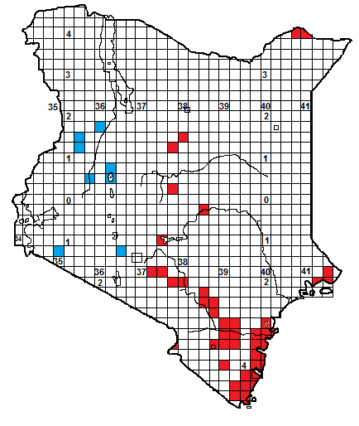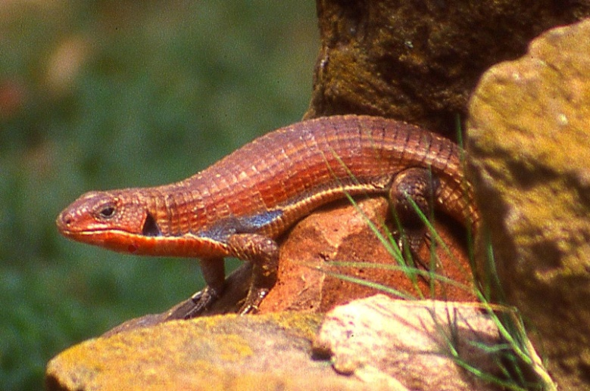

**Identification**: A large, stout lizard with big square scales and a large, triangular ear-opening. The body is thickset and compressed; a distinctive skin fold is present on the lower flanks. Those from east of the Rift Valley are usually some shade of brown, and males in the breeding season may develop a reddish (or even blue) throat. Those from west are darker, grey or black, with yellow striping, for a long time they were regarded as a separate subspecies, *Gerrhosaurus major bottegoi,* but at present are just recognised as a different colour morph. Juveniles are heavily marked with black. The maximum size is 55 cm (in Kenya, the only larger lizards are the monitors, *Varanus*), average 30-40 cm, hatchlings 14-16 cm.

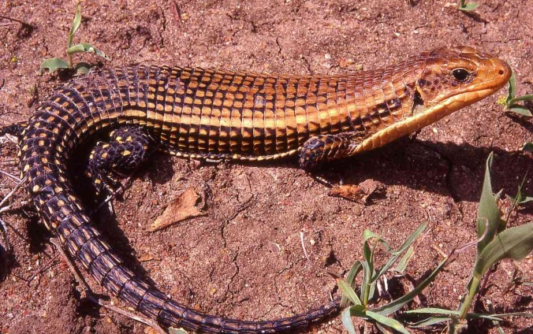 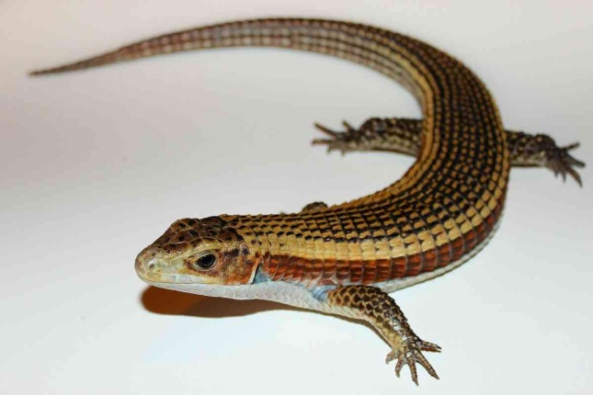

**Distribution**: Sporadically recorded from a wide range of habitats in Kenya. The brown form, from east of the Rift Valley, (red squares on map) is widely recorded in Ukambani, Tsavo, Kitobo Forest in Taveta and the coast; Ithanga Hills, Meru National Park and Isiolo, records from the north include Laisamis and Malka Murri. The darker form (blue squares on map) is known from Mt Suswa, Maasai Mara, Baringo, Amaler and parts of the Kerio Valley. Most abundant at low altitudes, but known from altitudes of close to 2000 m in parts of its range, usually in savanna, semi-desert or light woodland.

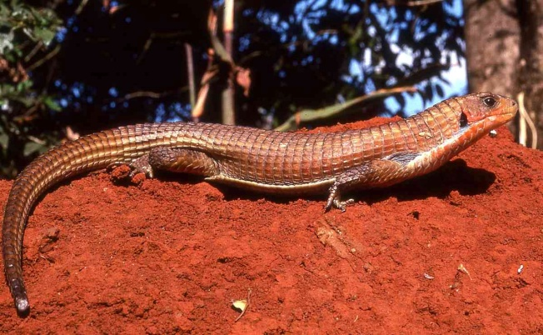 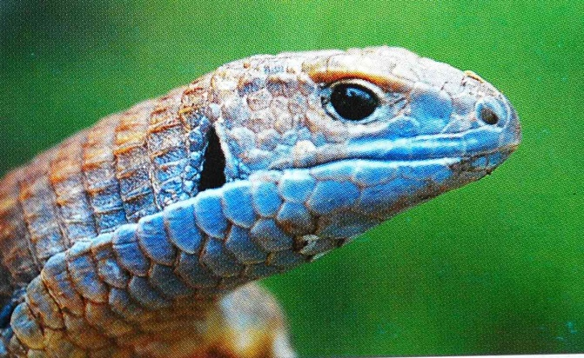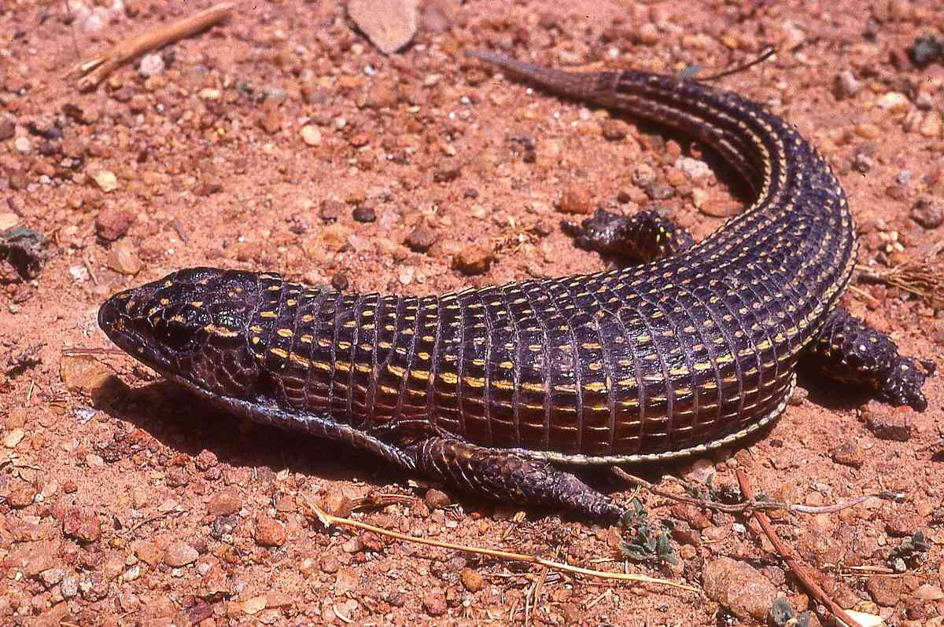

**Natural History**: Terrestrial and diurnal, living in holes which it digs itself, rock piles, rock crevices and termitaria, at the coast often in crevices in the coral rag. Fairly tolerant of urbanisation, especially at the coast. The males are territorial, and develop vividly coloured throats and fight in the mating season. Two to six eggs are laid in a deep damp hole or under a rock. Juveniles mostly eat arthropods but adults eat plant material as well, and may eat small vertebrates.

**Illustrations:** top adult, Tsavo East, upper middle left captive juvenile, upper middle right adult male, © Bethany Avilla, lower middle left adult, Kilifi, lower middle right blue-throated male, Isiolo, © Bob Drewes, bottom adult western form, Wa, Ghana.

**Yellow-throated Plated Lizard *Gerrhosaurus flavigularis***

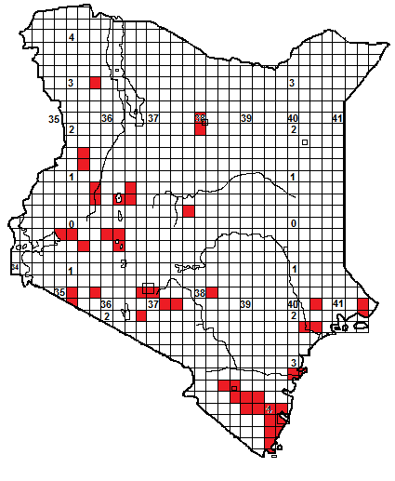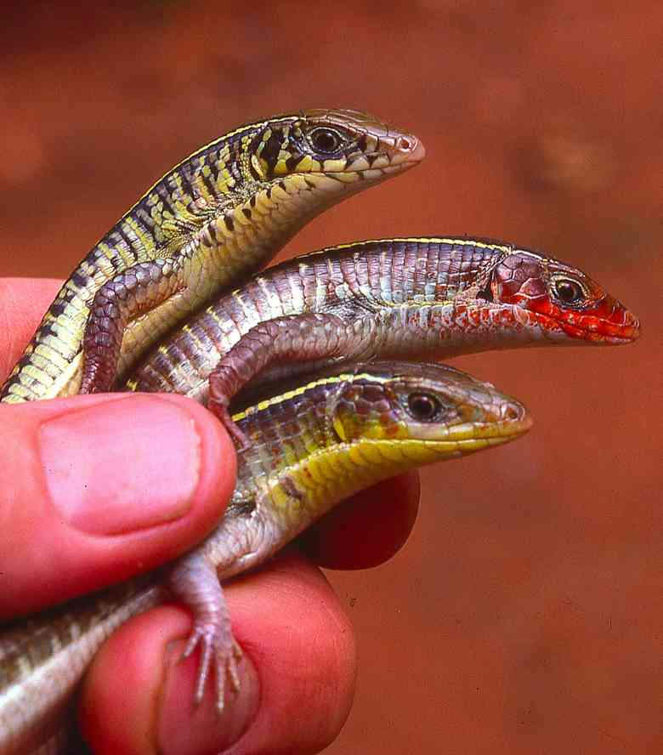

**Identification**: A slender striped lizard, quite large, with square scales, a distinctive skin fold on the lower flanks and a long tail, two-thirds of total length. The body is flattened. Colour usually brown, with a pair of dorso-lateral yellow and black stripes; the flanks sometimes have vertical yellow bars. Maximum size is about 40 cm, average 25-35 cm, hatchlings about 10 cm. Liable to be confused with the next species (black-lined plated lizard); technically they can be separated by the number of scales above the eye (five in this species, four in the black-lined plated lizard), but this species is slimmer in general appearance.

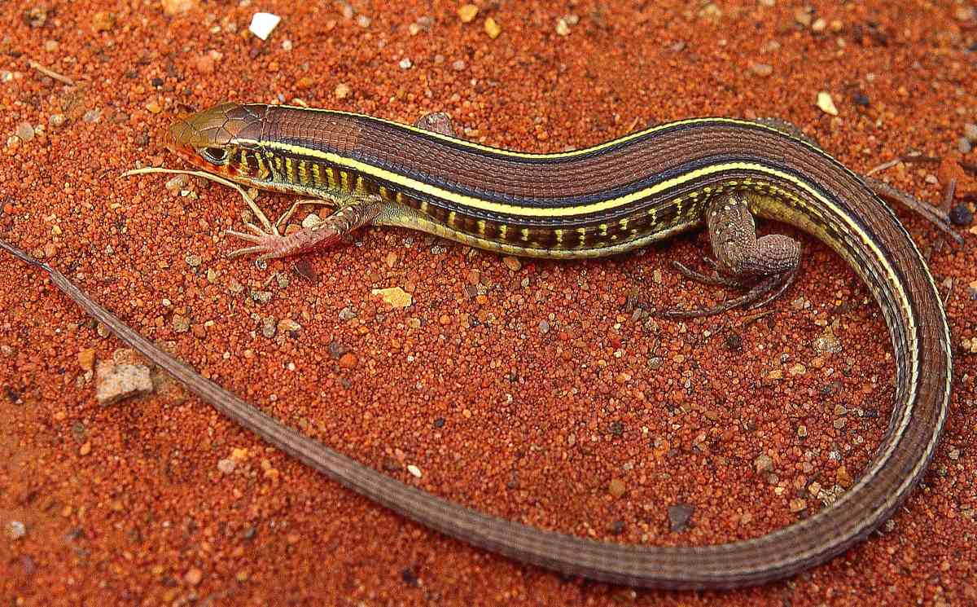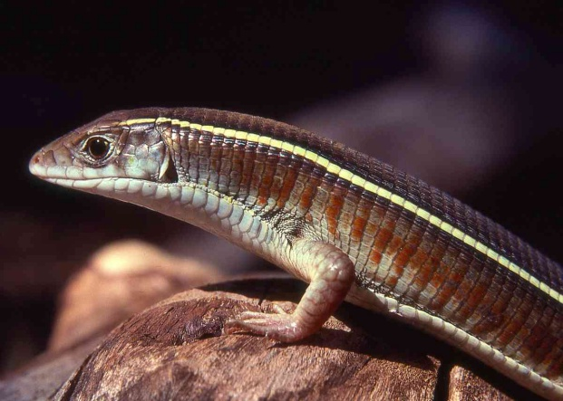

**Distribution**: Sporadically recorded from a wide range of habitats in Kenya, including the coast, (relatively common south of Mombasa), Shimba Hills, Mombasa, Malindi, Tsavo, Ukambani, the Athi-Kapiti plains, Nairobi, Nakuru; from sea-level to over 2000 m, in woodland, dry and moist savanna and grassland, but very few records from the dry north, save the Turkwell River, Isiolo and Marsabit.

**Natural History**: Terrestrial and diurnal, living in holes, vegetation heaps, under rocks, logs and similar ground cover. It is secretive and fast moving, liable to be mistaken for a snake as it rushes through the grass. In the breeding season the throats of adult males become suffused with bright colours. Three to eight eggs are laid, in a moist hole or in deep leaf litter. Hatchlings collected in the Kerio Valley in July. Eats a range of arthropods.

**Illustrations:** top male throat colours, Botswana, bottom Diani Beach.

**Black-lined Plated Lizard *Gerrhosaurus nigrolineatus***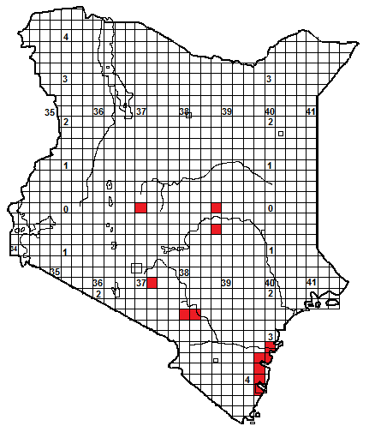 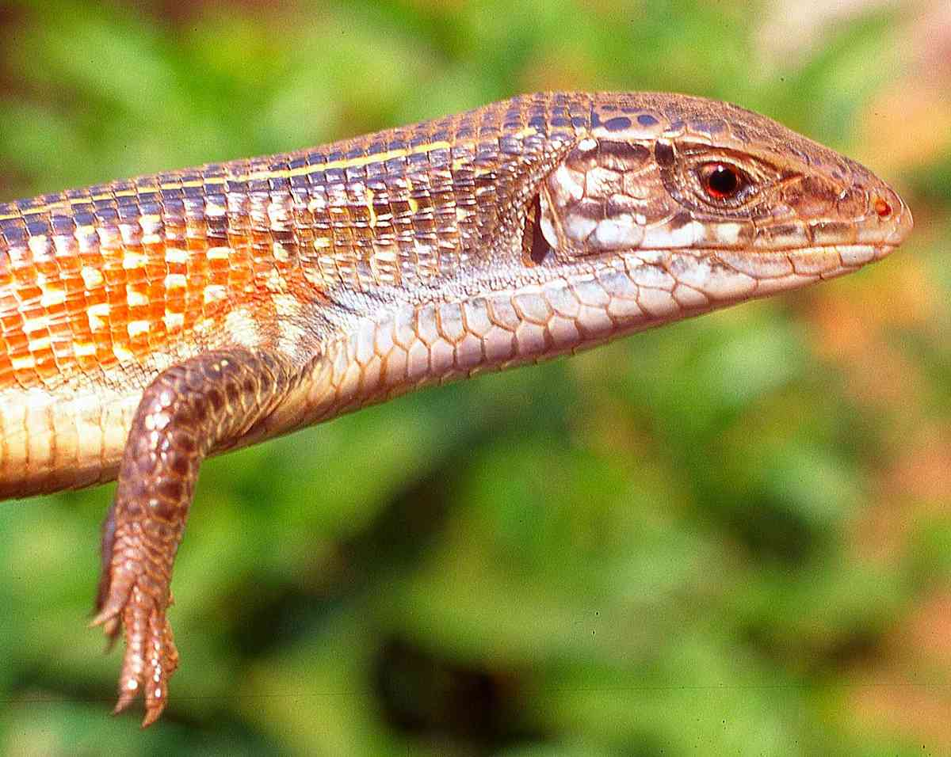

**Identification**: A long, striped, fast-moving slender lizard, with a long tail, the usual distinctive skin fold on the lower flanks and an obvious, triangular ear-opening. Usually brown above, with two prominent dorsolateral stripes, flanks grey, brown or rufous but often distinctively speckled with yellow. Throat may be blue-grey. The maximum size is about 45 cm, average 23 to 35 cm, hatchlings 14-16 cm.

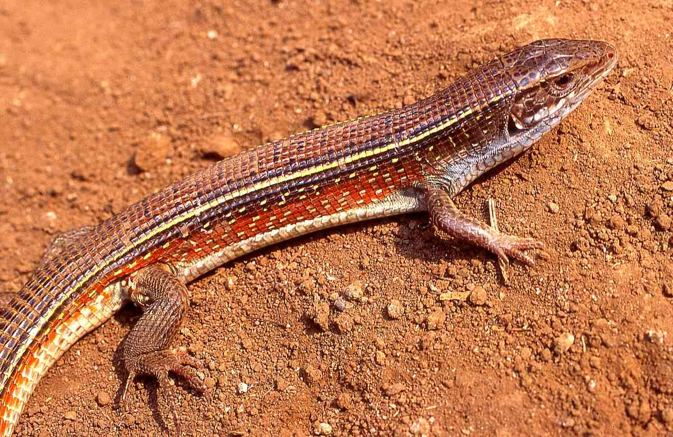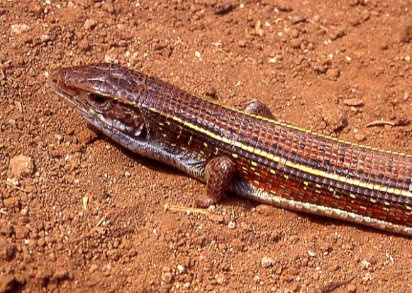

**Distribution**: Apparently rather rare in Kenya. Recorded in woodland along the coastal strip from Malindi south to Mombasa, and a handful of inland records, from high grassland, moist and dry savanna; inland localities include Kibwezi, Stony Athi, Burguret and Shaffa Dika.

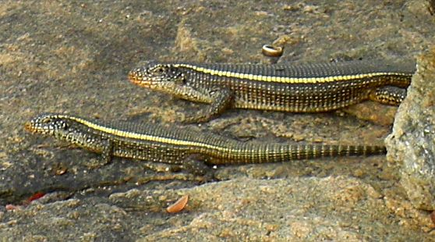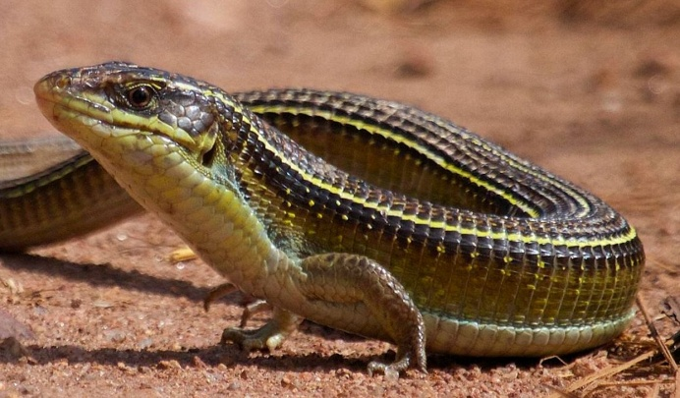

**Natural History**: Terrestrial and diurnal, living in holes, rodent burrows, termite hills, and squirrel warrens, under rocks, logs and similar ground cover. Shy and fast moving, although it will sometimes bask. Four to nine eggs are laid, in a moist hole, under a rock or in a rotten log. Eats a range of arthropods, and has been known to take snails.

**Illustrations**: Top three Arusha, bottom left Iringa, Tanzania (© Quentin Luke), bottom right Akagera, Rwanda (© James Hogg)

**Girdled Lizards**

A group of about 35 unmistakable, mostly small spiny lizards, largely occurring in the stony hills of southern Africa, with a small radiation into East Africa and Ethiopia. Originally in the genus *Cordylus*, some southern African species have been split into a further six genera, including some playfully allocated to a new genus, *Smaug*, (the dragon in J R R Tolkien’s fantasy adventures). Girdled lizards are stocky, with well-developed limbs. They live largely on rocks, a few live on trees, and an unusual hinge structure within the head enables them to jam themselves in cracks by clenching their jaws, which shortens and thickens the head. Secretive and retiring, they give live birth and eat mostly arthropods; some eat plants. Two species occur in Kenya, both in the south; interestingly another species is known from southern Ethiopia, so they might be in the intervening country.

**Tropical Girdled Lizard *Cordylus tropidosternum***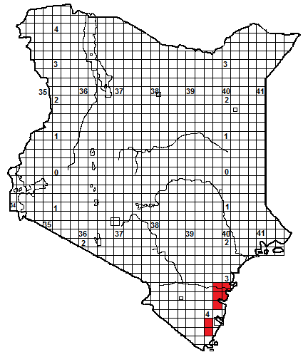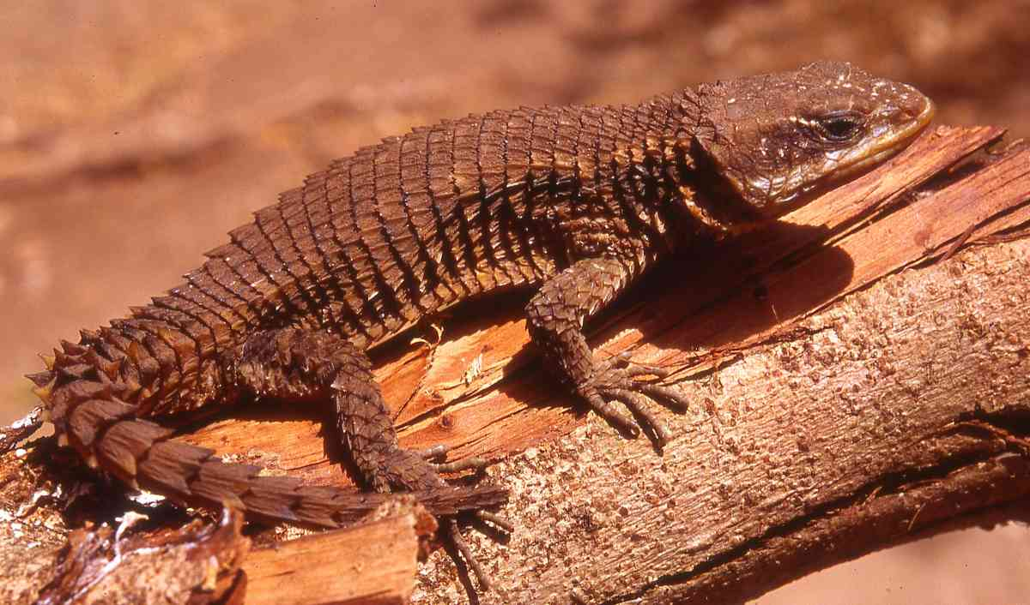

**Local Names:** Kinjon jonloka (kiGiriama)

**Identification**: A small, stout, spiky brown lizard, with a flattened body, narrow neck. The body scales are large and strongly keeled. The tail is short and slender, about 40% of total length. Usually brown in colour, with yellowish or tan flecking, lighter below. The maximum size is about 19 cm, average 14 to 17 cm, hatchlings 6-8 cm.

**Distribution**: In Kenya, known only from the forest and woodland of the coast, from the Arabuko-Sokoke Forest southwards to Kilifi and Shimba Hills National Park, although widespread in coastal Tanzania, thence to Zimbabwe.

**Natural History**: A diurnal, arboreal lizard; lives in trees, sheltering under bark and in holes. Usually slow-moving and secretive but can run fast; if approached it may freeze or move surreptitiously around the tree. They give live birth, up to three young. Diet mostly arthropods; has been observed in Kenyan coastal forests prising out moths and spiders from under dry bark.

**Illustration:** Arabuko-Sokoke Forest.

**Maasai Girdled Lizard *Cordylus beraduccii***

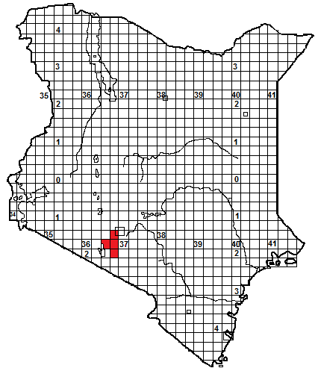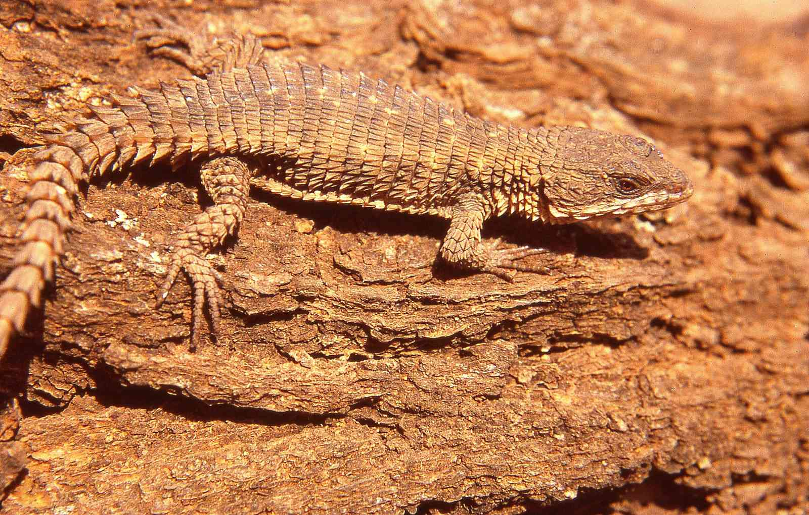

**Identification**: A small, stout, spiky speckled yellow-brown lizard, with a depressed body and a triangular head. The body scales are large and strongly keeled. The tail is short and slender, about 35% of total length. Usually brown in colour, with yellowish or tan flecking and an ill-defined lighter dorso-lateral bar, lighter below. The maximum size is about 11 cm, average 8 to 9 cm, hatchling size unknown.

**Distribution**: In Kenya, recorded sporadically from the mid-altitude savanna of the central south, known localities include the savanna west of the Ngong Hills, the hills on either side of the Nairobi-Magadi road as it descends from Corner Baridi to Olorgesaille, and around Kajiado.

**Natural History**: A diurnal lizard; lives on rock outcrops, sheltering in cracks, but also in trees where it hides under bark. Basks in the morning sunshine. They give live birth, a hatchling was captured west of the Ngong Hills in September. Diet mostly arthropods.

**Illustration:** Southern end of Ngong Hills.

**Snake or Grass Lizards *Chamaesaura***

A south-east African genus of five species of effectively legless, slim diurnal lizards that glide rapidly through grass, they look like and could be mistaken for snakes. Their limbs are rudimentary spikes or buds. Their tails (which can be shed) are much longer than their bodies. They have elongate scales that give them a strange artificial look. A single species occurs in Kenya.

**East African Highland Grass Lizard *Chamaesaura tenuior***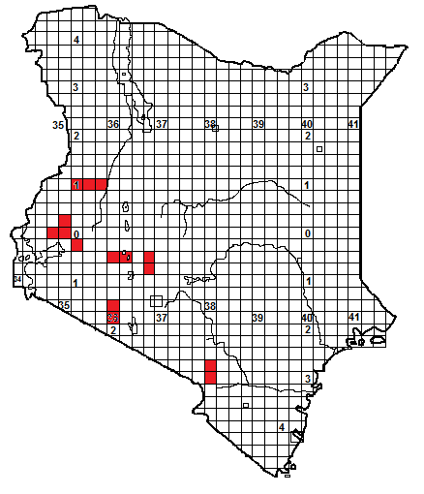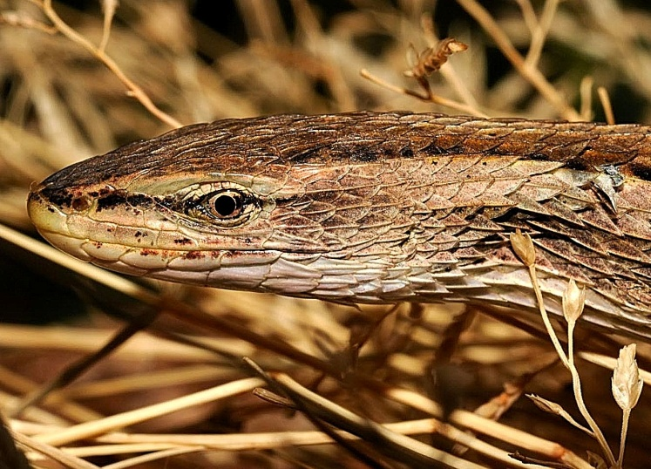

**Identification**: A slim, apparently legless lizard with a very long tail, two or three times the body length, or more. The tiny stick-like limbs have minute clawed digits. Striped; usually below the black-edged, brown vertebral stripe is a tan stripe and below that a brown stripe, but the amount and colour of striping varies. Underside brown or yellow, with fine lines. The maximum size is about 60 cm, average 30 to 50 cm, hatchlings 17-18cm.

**Distribution**: In Kenya, recorded from grassy areas in high altitude savanna and on hill ranges, known localities include the Chyulu Hills, Lebetero and Loita Hills, Aberdares, Cherangani Hills, Kakamega area and the Mau Escarpment.

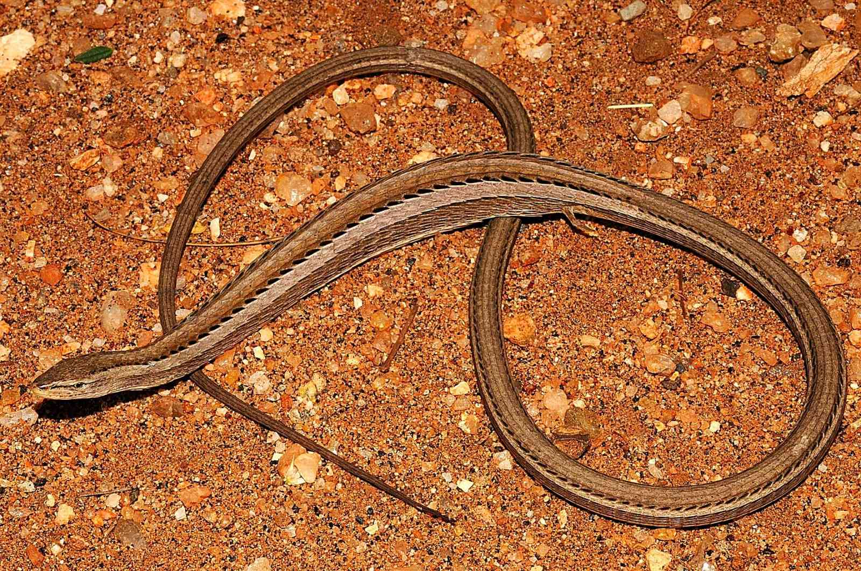

**Natural History:** Diurnal and terrestrial, although they climb up in grass tufts. At night they hide in tufts or under ground cover, they emerge to bask and then hunt. If threatened they glide rapidly away and hide in a grass clump. They give live birth, to two to nine young. Their diet includes grasshoppers and other arthropods.

**Illustrations:** Lebetero Hills, Loita, © Miloslav Jirku.

**Monitor Lizards Varanus**

The monitor family includes the world’s largest lizards. More than 80 species are known, many described recently due to systematic studies splitting ‘species complexes’. Monitors are largely big, carnivorous, fast-running diurnal lizards with powerful limbs; they have forked tongues. Their whip-like tails cannot be shed but they can lash them with remarkable accuracy. Monitors occur from Australasia (where they are called goannas and show the greatest diversity) to Asia and Africa, although only five species occur in Africa. The Komodo dragon, *Varanus komodoensis*, a monitor, is the world’s largest lizard, reaching 3 m length and 160 kg in weight; the Asian water monitor (*Varanus salvator*) is the longest lizard in the world, reaching 3.5 m. Recent research has suggested they have unusually toxic saliva, which may assist with immobilising prey, but not all scientists accept this hypothesis.

**White-throated Savanna Monitor *Varanus albigularis.***

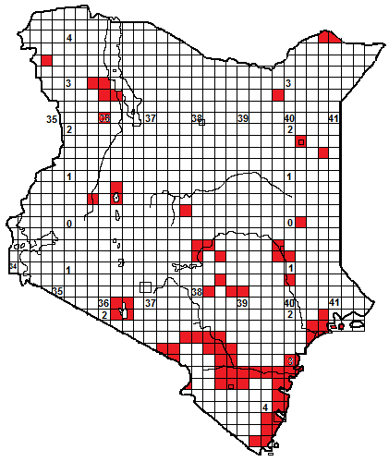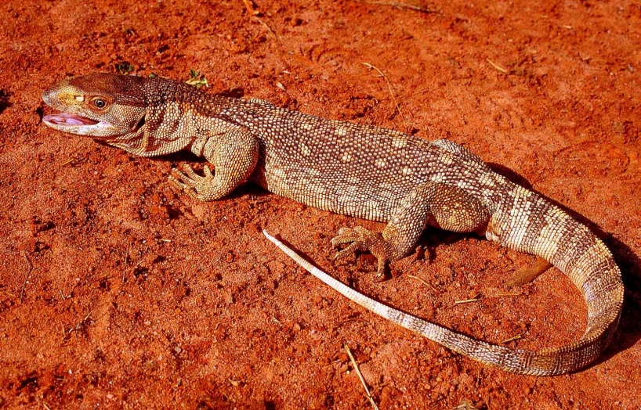

**Local Names:** Kenge, Mburukenge (Swahili), Njaana (Kikuyu), Nzaana (Kamba), Ng’ech (DhoLuo), Kiprerino (Kalenjin), Ayole (Turkana), Embulu (Luhiya), Murikati (Embu), Nchaana (KiTharaka) (all generic, applying to all monitors).

**Identification:** A heavily built, largely brown or grey monitor lizard, the head is deep with a small obvious eye and big nostril close to the eye socket. The tongue is long, forked and blue. The body is stocky, the tail long and triangular in cross-section, with a hard ridge on the top. A broad dark stripe extends from the top of the head onto the back, which is marked with pale circular eye-spots, arranged roughly in bars, and the tail is barred light and dark. However, large individuals often just look dull brown, with indistinct pale spots on the back and faint tail barring. Adult monitors of both species can be identified with certainty by size; no other Kenyan lizard reaches more than 60cm. Adult savanna monitors average 1 to 1.4 m, and may reach 1.6 m, hatchlings are about 25 cm.

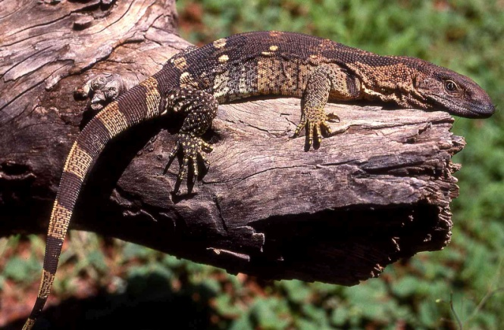 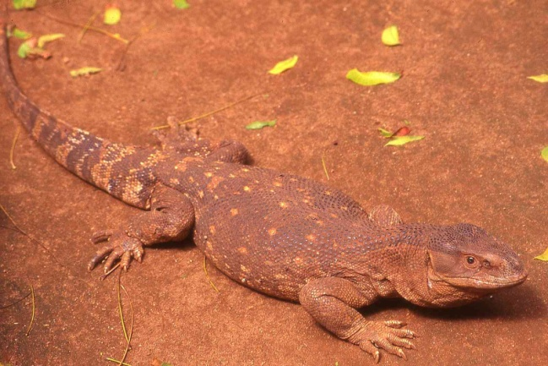

**Distribution.** This lizard occurs widely throughout the low-altitude areas of Kenya, in semi-desert, dry and moist savanna, woodland and coastal thicket. Very rare above 1 500 m altitude, not found in Nairobi National Park, for instance. It is abundant and easily observed in Tsavo, Kitobo Forest and Ukambani and many places on the coast. Museum records from the north more sporadic, especially the central north, although this might just be due to the difficulty of preserving such a large animal. No records at all from the southwest.

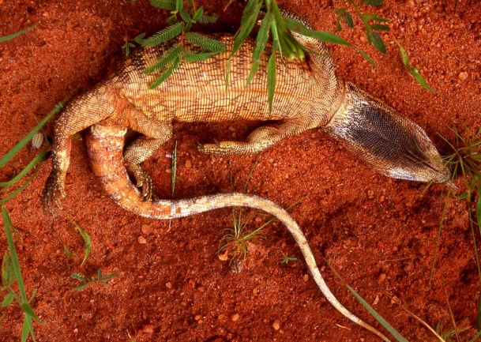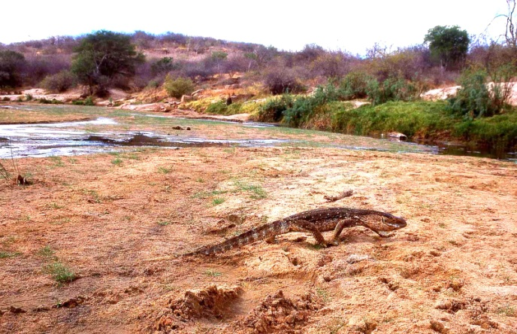

**Natural History:** Diurnal, mostly terrestrial but it climbs well, if clumsily, ascending big trees and rock outcrops to a considerable height. Shelters in thickets, holes, rock fissures, tree holes and abandoned termite mounds, but also sleeps out on tree branches, and if panicked will jump. During the dry season it is often inactive, remaining motionless in its refuge (although specimens have been observed simply dormant on the side branch of a big tree). Abundant in some areas (one small rocky hill on the Tharaka plain had twelve individuals living on it), rare in others. In some places it is tolerant of humans, in others more nervous. Studies in southern Africa indicate savanna monitors have home ranges of several square kilometres and they walk 3-6 km per day, looking for food. They lay between 8 and 50 eggs, often in a termite hill or in a hole dug by the female. They eat any small animal they can overpower, their diet includes small vertebrates (including tortoises and venomous snakes), arthropods, even carrion.

**Illustrations:** Top Galana River, middle left captive, southern Africa, middle right Malindi, lower left Mtito Andei, lower right Tiva River.

**Nile Monitor *Varanus niloticus***

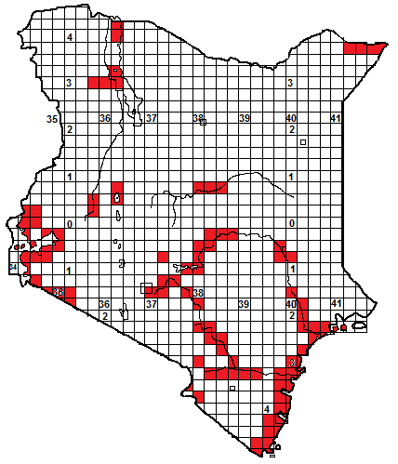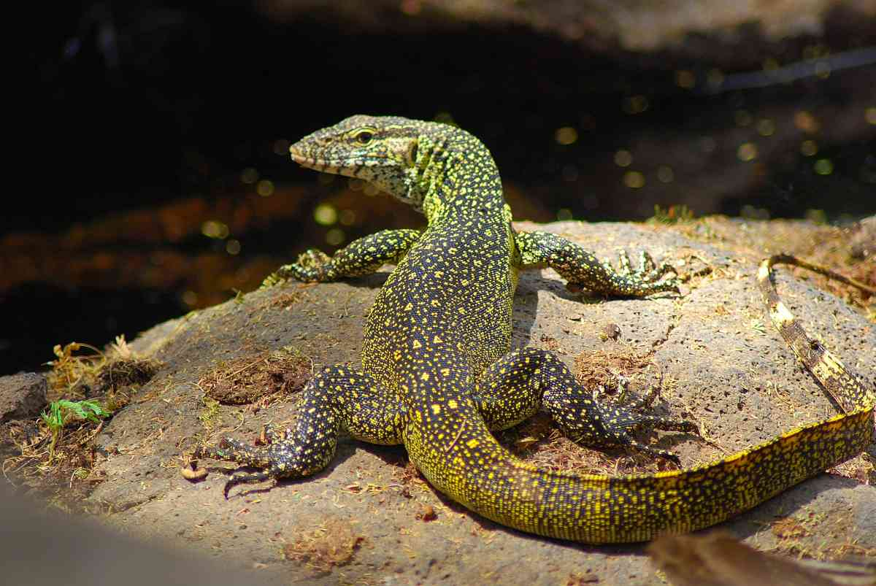

**Local Names:** As for the savanna monitor, most names apply to both species.

**Identification:** A big dark green and yellow monitor lizard, Africa’s biggest lizard. In some adults, the dark green becomes almost black. It has a pointed snout. The tongue is long and forked. The body is slim, the tail long and triangular in cross-section, with a hard ridge on the top; the skin is tough and leathery. Dorsal background colour dark green or black, marked to a greater or lesser extent with yellow or yellow-green dots and eyespots, which may form 6-11 crossbars on the body; the tail has 11-18 yellow bars interspersed with dark. Underside yellow to white with dark bars. Usually identified with certainty by size, adult Nile monitors average 1.2 to 2.2 m, there are anecdotal reports of specimens close to 3 m long from the Tana River. Hatchlings are about 25-30 cm.

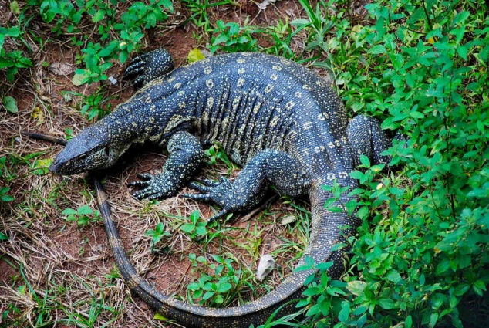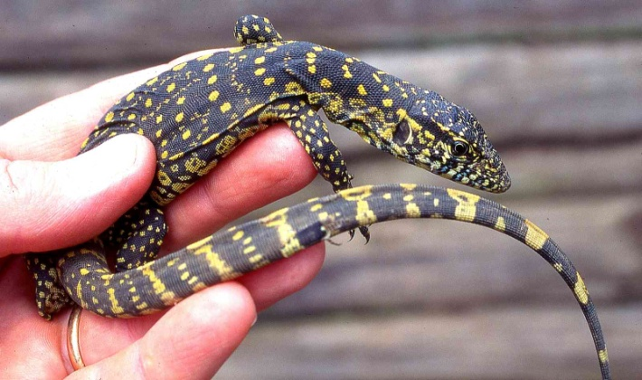

**Distribution**: Usually near fresh water sources, from sea level up to about 1 600 m altitude, reaches Nairobi National Park but is not in Lake Naivasha. Occurs the length of most of Kenya’s permanent rivers, like the Athi-Galana-Sabaki system, coastal rivers including the Ramisi and Mukurumudzi and smaller rivers of the Shimba Hills, Njoro Spring River at Kitobo Forest, the Daua, the Tana, parts of the Uaso Nyiro, the Turkwell, the Mara rivers below 1 700 m, and all around the shores and on the islands of Lake Victoria. Only in two rift valley lakes, Baringo and Turkana, known also from Lake Jipe.

**Natural History:** A diurnal fast moving versatile lizard, usually fairly close to water, it climbs rocks and trees; often basks in riverside trees and when disturbed will jump into the water. Nile monitors swim superbly; limbs tucked in, and can stay submerged for up to 20 minutes. When inactive hides in thickets and holes. Usually wary, runs away rapidly if disturbed. Forages on land and in the water; they have a varied diet which includes freshwater crabs and mussels, invertebrates and small vertebrates including fish, frogs, other reptiles, birds and their eggs and small mammals. They raid unattended crocodile and freshwater turtle nests and have an excellent sense of smell, they will find carrion and have been known to raid chicken runs. They lay 15-60 eggs, the female may claw her way into an active termite hill to lay the eggs. In southern Kenya hatchlings have been observed in January, and July in northern Kenya; a clutch of 17 hatched in late April at Watamu. Like other monitors, if cornered they inflate the throat, hiss loudly, stand up high and lash with their tails, they have a hard bite.

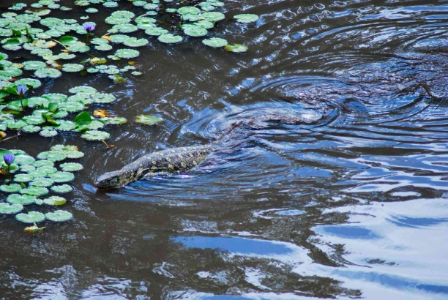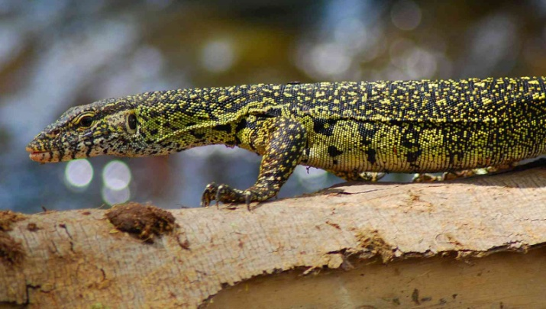

**Illustrations:** Top and bottom right, Mzima Springs, middle left and bottom left Shimba Hills, middle right juvenile Arusha.